Experiment 7
Navigation and Copy Commands
Aim
To execute cd, cp, and ls commands.

Procedure
1. Navigate between directories using cd.
2. Copy files using cp.
3. Verify copied files using ls.

Output
cd Command
Changes the current directory.
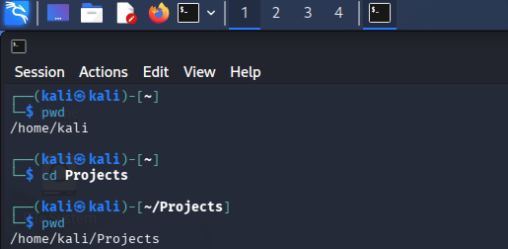
cp Command
Copies files and directories.
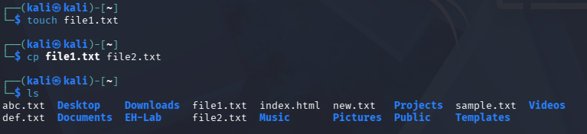
Result
Successfully executed cd, cp, and ls commands.

